**Exercises Strings**

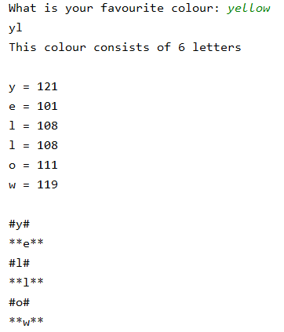**Exercise 1**

Write a program to read a colour. Then print out the following information:

* The first and third letter of the colour
* How many letters the colour name consists of
* All the letters of the colour one by one with the ASCII code of each letter next to it **(use a for)**
* All the letters of the colour underneath each other **(use a while).** 
  + for the1st, 3rd, 5th ... letter add # at the front and at the back
  + for the 2nd, 4th, ... letter add ** at the front and at the back

**Exercise 2 (do not use for or while)**

Write a program to read a word and a number. Then print a new word consisting of the first character followed by the last 'number' of characters from the given word.

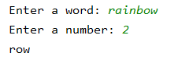

**Exercise 3 (do not use for or while)**

Write a program to read an odd-length string. Print the middle three characters of this string. You may assume that the string contains at least 3 characters.



**Exercise 4**

A palindrome is a 'symmetrical' word. This means: whether you read it forwards or backwards, you get the same result.

Examples: radar, anna, level, racecar

Write a program to read a word and print out whether it is a palindrome or not.

 

**Exercise 5**

A triple in a text is a character that occurs 3 times in a row. Write a program to count the number of triples in a text. The triples may overlap, as in the second example!

Make sure that the answer you print is grammatically correct! (There **is** 1 triple – There **are** 4 triples)

|  |  |
| --- | --- |
|  |  |
|  |  |

**Exercise 6**

Write a program to read a string and form a new string. The characters are changed into groups of 3. If there was *abc* in the original string, it will be *bca* in the new string*.*

This process is repeated for all subsequent groups of 3. The last remaining (1 or 2) letters are simply added.

|  |  |
| --- | --- |
|  |  |

**Exercise 7**

Write a program that reads a string and prints how big the largest block of characters is. A block is a series of characters that lie next to each other and are the same. You may assume the string isn't empty.







**Exercise 8 (do not use for or while)**

Write a program that reads a word and checks if the word ***in*** appears in the string in the first or second place. Use a String method for this.









**Exercise 9 (do not use for or while)**

Write a program that reads a string and prints the text between the first and second time *sandwich* occurs. If *sandwich* doesn't occur twice, you give the empty string as a result.







**Exercise 10**

Write a program that reads 5 words and prints the sentence in which those words are listed in reverse order. Whether you type the words in upper or lower case, they will be placed in the sentence with only an uppercase letter in front.

Pay attention to the sequence number that is passed on each time you read it!

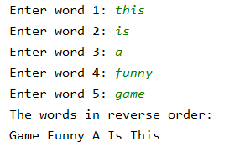

**Exercise 11**

Write a program to read a string and check if every **x** has a **y** further on in the string.







**Exercise 12**

Write a program to read a string and create a new string in which every * but also every character in front of and behind that * is gone.

You may assume that the * does not appear on the first or last place.





**Exercise 13**

Write a program that first asks to enter a name. The program stops when you don’t enter a value but press enter.

If you enter a name, you will see a drop-down menu in which you determine whether you want to print your name in upper case, lower case or alternating upper and lower case.

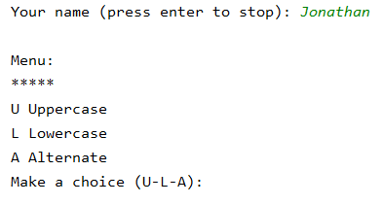

The drop-down menu continues to appear until you enter a correct value (U, u, L, l, A, a).  
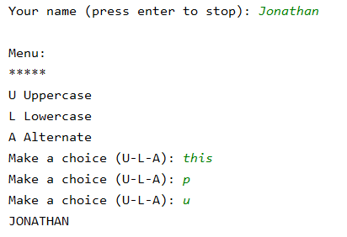

When you enter U or u, you get



When you enter L or l, you get

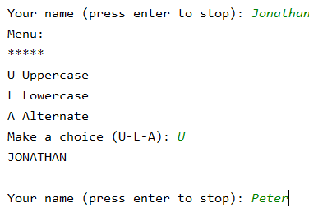

When you enter A or a, you get



After you have made a choice, you can enter another name.